Reel or Real? A Context-Aware Deepfake Detection and Verification Framework
- Introduction & Project Scope
The proliferation of deepfakes - highly realistic synthetic videos generated using advanced AI architectures such as Generative Adversarial Networks (GANs), transformers, and diffusion models - presents a significant threat to digital integrity and public trust. By mimicking the appearance and voices of real individuals, deepfake videos are increasingly used to mislead audiences, manipulate information, and erode institutional credibility.

This project proposes a context-aware deepfake video detection and verification framework. In this context, "context-aware" refers to the system’s ability to reason beyond visual signals by integrating multimodal features, metadata analysis, and source verification into the decision process. The system is designed exclusively for detecting AI-generated videos, with future extensibility to image-based deepfakes.

The framework adopts a hybrid architecture of convolutional neural networks (CNNs) and transformers to model both spatial and temporal patterns in deepfake videos. It incorporates explainable AI techniques such as heatmaps and attention maps, a user-friendly interface to support transparency, and cryptographic watermarking for provenance verification. The project aims to deliver a detection tool that is robust, transparent, and ethically grounded, and suitable for deployment in real-world environments.

- Rationale & Background Research
While deepfake detection has received growing academic attention, most systems still suffer from poor generalisation, limited multimodal integration, and low interpretability. CNN-based detectors like Xception and ResNet (Pan et al., 2020; Ahmed et al., 2022) perform well on curated datasets but often fail on unseen or real-world content. Transformer-based models (Gong & Li, 2024; Zhang et al., 2025) offer improved temporal modelling but remain black-box in nature, limiting their transparency and trustworthiness.

Dataset quality also remains a major factor. Early benchmarks such as FaceForensics++ and the Deepfake Detection Challenge lack diversity and real-world complexity (Lyu, 2020). In contrast, more recent datasets like KoDF, HAV-DF, and WildDeepfake support better generalisation across demographics, while FakeAVCeleb introduces complex audio-visual scenarios for multimodal learning (Khalid et al., 2021).

Research has also begun to explore provenance-based validation. Standards like C2PA (Laskar, 2025) embed verifiable metadata, while cryptographic watermarking (Walczyna et al., 2025; Wang et al., 2025) offers tamper-evident content tracking. However, such methods are rarely integrated into deep learning pipelines.

Key gaps persist as models often generalise poorly across datasets; audio-visual fusion remains underdeveloped; explainability features are lacking; provenance tools are seldom embedded; and user-centric design is rarely prioritised. This project addresses these challenges by developing a unified, explainable, and ethically responsible deepfake video detection framework, grounded in multimodal learning and real-world usability.

- Project Development: Approach & Evaluation
The proposed system will follow a modular hybrid architecture that combines CNNs and transformers. The CNN backbone will extract spatial features from individual video frames, while the transformer component will model temporal dependencies across sequences. To incorporate audio information, the system will use Mel-frequency cepstral coefficients (MFCCs), allowing for the alignment of audio patterns with their corresponding visual frames. This multimodal approach is intended to detect inconsistencies in both synchronisation and content, which are often indicative of deepfake manipulations.

The framework will be trained and evaluated using a focused selection of publicly available deepfake video datasets. For core implementation, three datasets will be used: the Deepfake Detection Challenge (DFDC) for large-scale and diverse video content, FakeAVCeleb for challenging audio-visual fusion scenarios, and KoDF (Korean Deepfake Dataset) to ensure linguistic and demographic diversity. Together, these datasets provide a robust foundation for training and evaluating multimodal models. Additionally, a user-contributed dataset, containing videos, audio, and images from over 350 participants, may be incorporated pending university ethical approval, offering real-world variability and authenticity.

While datasets such as FaceForensics++, HAV-DF, and WildDeepfake have also been reviewed during the literature phase, they are not part of the current implementation plan. However, they remain viable for future evaluation and extension, particularly in exploring cross-domain generalisation and static image detection. The framework is designed to accommodate such extensions as part of ongoing research beyond the initial project scope.

To enhance transparency and user trust, the system will embed explainable artificial intelligence mechanisms directly into its inference pipeline. Grad-CAM heatmaps will be used to highlight areas of visual interest, while transformer-based attention maps will offer insight into how sequential information contributes to classification decisions. Confidence scoring will be displayed alongside each output, quantifying the model’s certainty. Furthermore, the framework will integrate metadata verification aligned with the Coalition for Content Provenance and Authenticity (C2PA) standard, allowing users to assess the source integrity of submitted content. These explainability and provenance tools will be presented through a user-facing interface designed for accessibility and interpretability.

Model evaluation will involve both quantitative and qualitative methods. Quantitative assessment will include standard metrics such as accuracy, precision, recall, F1-score, and robustness against compression or distortion. These will be benchmarked across DFDC, FakeAVCeleb, and KoDF to assess generalisability. Qualitative evaluation will be conducted through a small user study, focusing on how clearly the system communicates its decisions and how much trust users place in its outputs.

- Feasibility, Planning & Gantt Outline
The system will be developed using Python, leveraging PyTorch, TensorFlow, and OpenCV as the primary libraries for model implementation and data handling. A GPU-supported laptop is available to support local training, while scalable cloud computing platforms such as Google Colab Pro may be used to accommodate more computationally intensive tasks. The architecture will be designed exclusively for detection and verification purposes; no component of the system will be capable of generating synthetic content. This design choice ensures alignment with responsible AI practices and reduces ethical and legal risks associated with content creation.

To ensure ethical compliance, all datasets employed in the project will either be openly licensed or approved by a university ethics committee. The user-contributed dataset, sourced from over 350 participants, may be used only upon formal university ethical approval. Participants will provide informed consent, and all submissions will be anonymised and stored securely. The system will operate in accordance with the General Data Protection Regulation (GDPR) and institutional ethical guidelines, including routine audits for fairness and demographic bias throughout the development lifecycle.

Task | Duration | Key Activities | Exp. Outputs
Proposal & Foundation | Weeks 1-5 (Oct-Nov) | Define project scope, conduct in-depth literature review, and analyse available datasets (e.g., FaceForensics++, HAV-DF, WildDeepfake) for background context. Finalise core datasets for implementation (DFDC, FakeAVCeleb, KoDF) and prepare project proposal. | Project scope statement, annotated bibliography, proposal submission.
Contextual Report & System Design | Weeks 6-13 (Nov-Jan) | Submit ethics documentation for survey dataset. Conduct detailed system design using UML and architectural diagrams. Implement and evaluate a baseline CNN model; compile contextual report. | Ethics submission, architecture diagrams, contextual report.
Implementation, Testing & Evaluation | Weeks 14-23 (Jan-Mar) | Build full data-processing pipeline; train and evaluate CNN, transformer, and multimodal fusion models. Conduct explainability integration and user studies to assess trust and usability. | Trained models, evaluation results, explainability visuals, user survey analysis.
Final Evaluation & Submission | Weeks 24-28 (Mar-Apr) | Consolidate quantitative and qualitative data. Write and proofread final report, prepare presentation slides, final demo, and submit all deliverables. | Final report, presentation, code submission, and project demonstration.

Potential risks include dataset imbalance, limited computational resources, and overfitting. Mitigation strategies include data augmentation, cloud-based training, and early stopping. The project’s structured timeline and modular design ensure successful completion within the academic year.
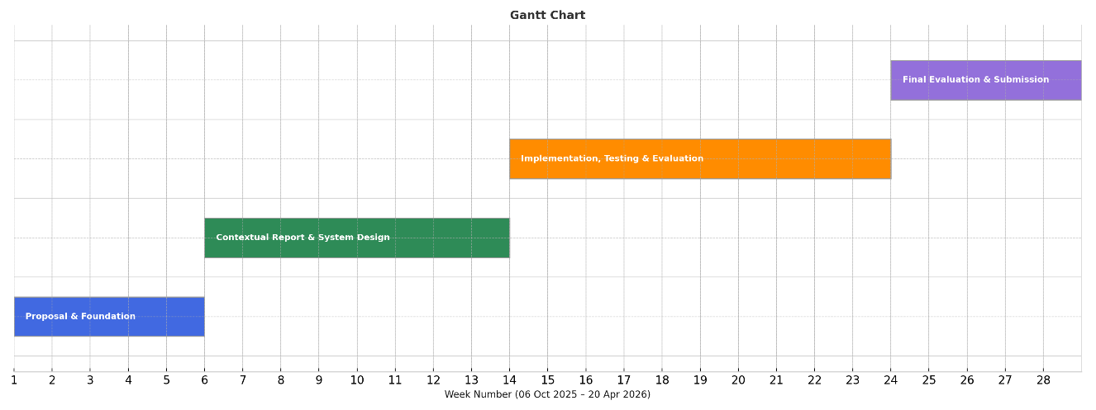

- References
Paper | Objective | Algorithm | Dataset | Methodology | Evaluation & Findings
Ahmed et al. (2022) | Survey CNN-based detection methods | CNNs (VGG, ResNet) | FaceForensics++, DFDC | Comparative literature review | Accuracy, precision - CNNs perform well but generalise poorly
Gong & Li (2024) | Review detection algorithms and datasets | CNNs, Transformers | KoDF, DFDC, WildDeepfake | Broad SoTA review | Mixed metrics - Transformers generalise better but are less interpretable
Heidari et al. (2023) | Systematic review of DL-based detection | CNNs, GANs, RNNs | DFDC, FaceForensics++ | Categorisation and taxonomy | Varied metrics - Hybrid models outperform single CNNs
Lyu (2020) | Discuss detection challenges and next steps | Overview | N/A | Conceptual/position paper | No metrics - Highlights trust, robustness, and generalisation issues
Khalid et al. (2021) | Release FakeAVCeleb multimodal dataset | CNN + audio alignment | FakeAVCeleb | Dataset creation + baseline evaluation | AUC - Multimodal fusion improves accuracy
Kaur et al. (2024) | Develop Hindi A/V deepfake dataset | Audio-video fusion | HAV-DF | Synthetic data generation | AUC, F1 - Hindi deepfakes pose distinct challenges
Kwon et al. (2021) | Create Korean deepfake dataset | Deepfake gen. + CNN | KoDF | Dataset curation + benchmarking | Accuracy - Supports model generalisation across ethnic groups
Zi et al. (2020) | Release real-world video dataset | Benchmark eval | WildDeepfake | Web scraping + annotation | Accuracy - High variability, useful for generalisation
Pan et al. (2020) | Test CNN for video detection | Xception | FaceForensics++ | Model training + testing | Accuracy - High on benchmark data but limited generalisation
Laskar (2025) | Explore ethical provenance tracking | Metadata (C2PA) | N/A | Technical + ethical review | N/A - Provenance enhances trust in source media
Walczyna et al. (2025) | Undo deepfake swaps via watermarking | RE-Mark | Synthetic face-swaps | Watermark embed + recovery | Identity recovery rate - Effectively restores original identity
Wang et al. (2025) | Initiative-taking tamper detection | FractalForensics | Synthetic videos | Watermark injection + detection | Precision, recall - Accurately localises manipulations
Zhang et al. (2025) | Build robust multimodal detection model | MFCLIP (Transformer + CLIP) | Diffusion Face Dataset | Contrastive learning + fusion | F1-score - Excellent on unseen forgery types

